Assignment

Submitted to Mam Yasmeen Jana
Submitted by Sahwana Ilyas
Registration no SP24-BSE-025
Course Web Technologies
Date 27-03-2026

COMSATS University Islamabad
Vehari Campus



Q: Use your knowledge of HTML, CSS, JavaScript, and Bootstrap to code a responsive and interactive quiz application. The application should present multiple-choice questions, track progress with a multi-colored segmented bar, enforce a countdown timer, dynamically highlight correct and incorrect answers, support dark/light mode, and allow users to download results as a PDF. Demonstrate the functionality by using at least five randomized questions and ensure the application works seamlessly across different devices.

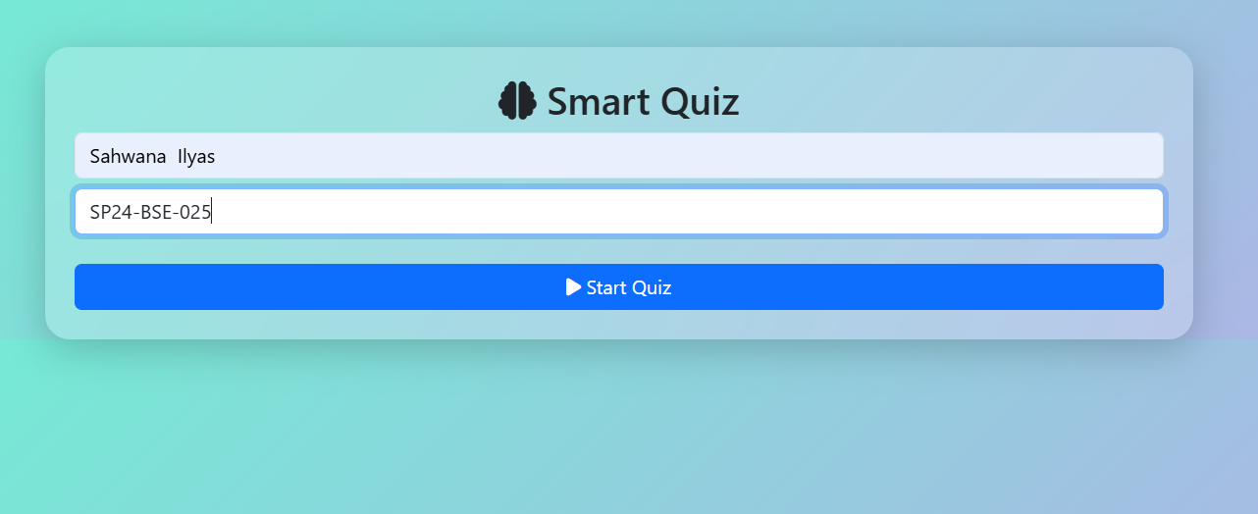
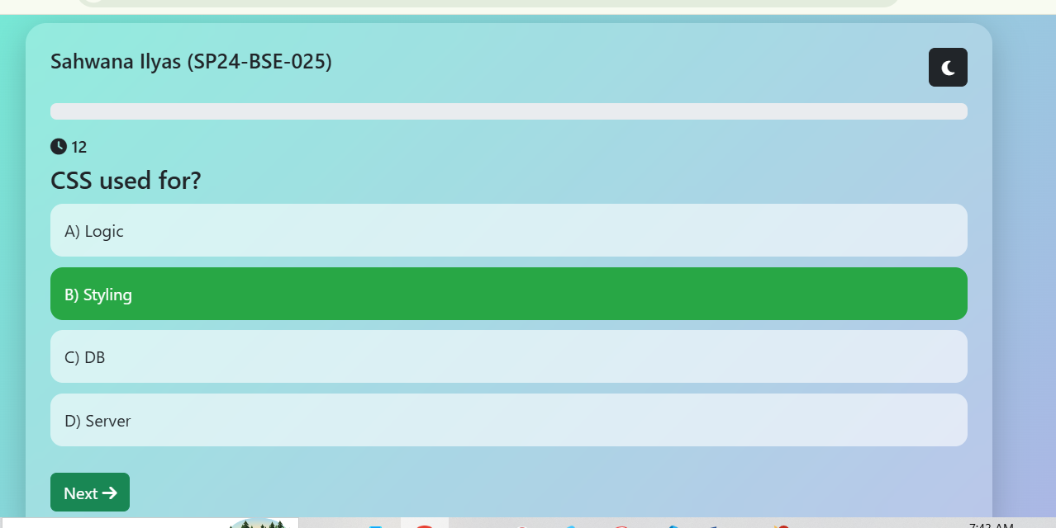
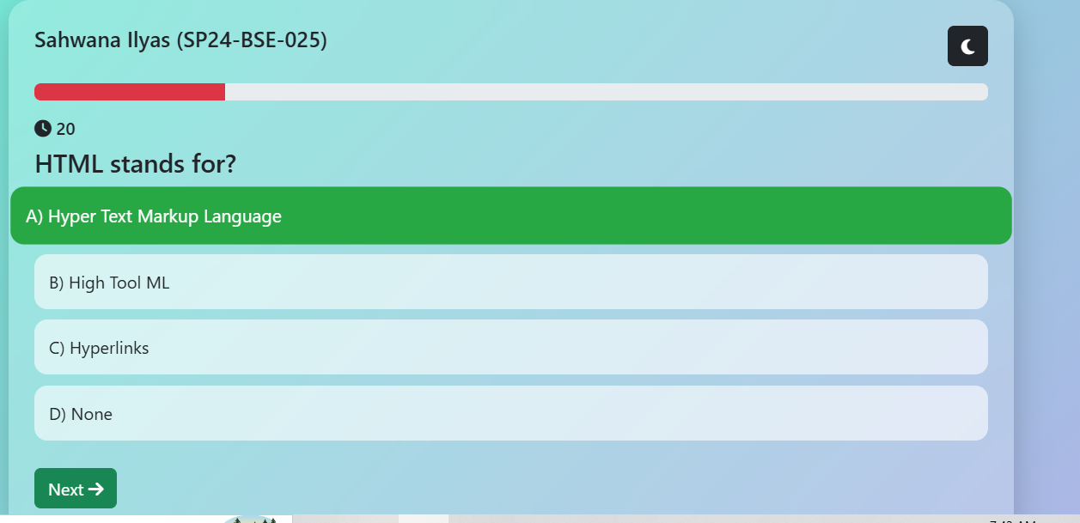
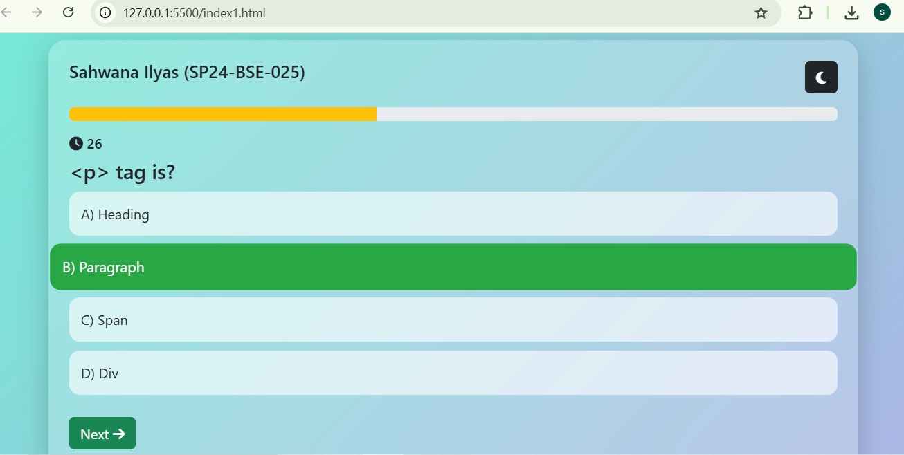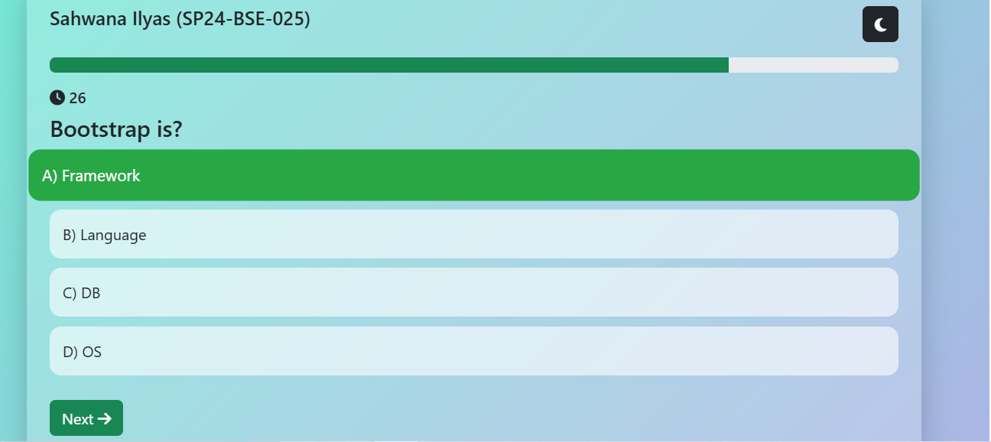
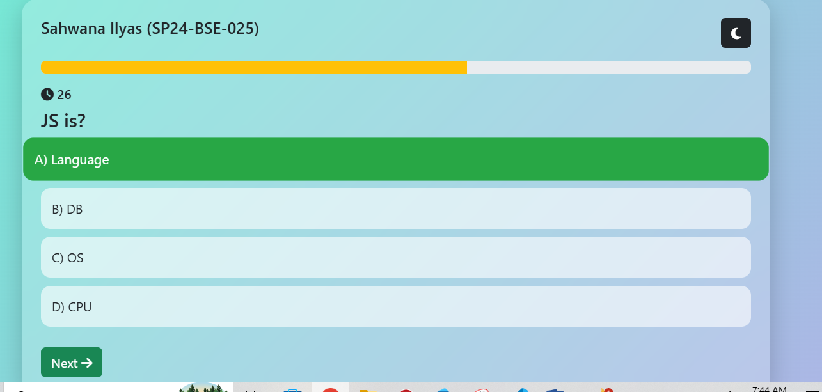
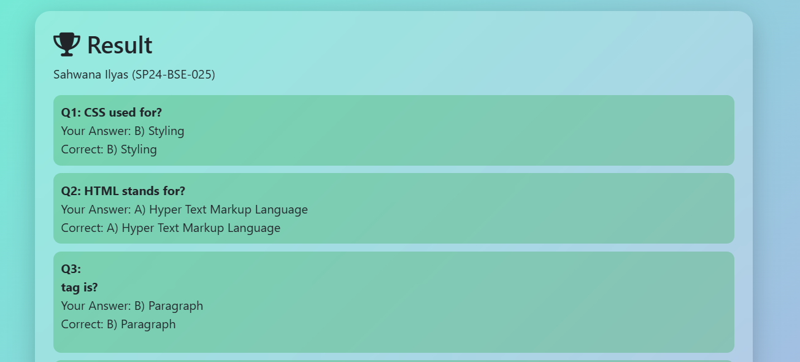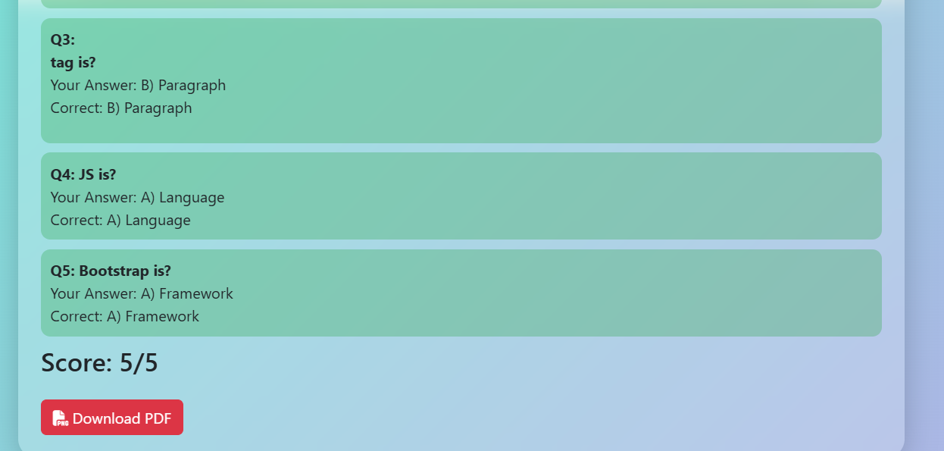
OUTPUT of Quiz :
